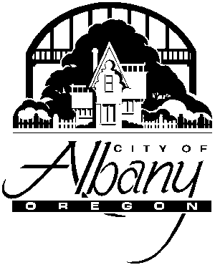Albany Public Library
2450 14th Avenue SE
Albany, OR 97322-6880

Facility Use Agreement

NAME OF AGENCY/GROUP:____________________________________________________________________
(Please Print)

User Acceptance

I acknowledge that I have received a copy of the Albany Public Library Facility Use Policy and that my agency/group will comply with the policy and procedures while using the Library. I understand that if my agency/group fails to comply with the policy or if there is damage to Library facilities because of my agency’s or group’s actions, future use of Library facilities will be denied.

NAME (please print):_____________________________________________________________________

TITLE: ______________________________________________________________________________

PHONE NUMBER: ____________________________________________________________________

E-MAIL ADDRESS: ___________________________________________________________________

ADDRESS: ___________________________________________________________________________

CITY, STATE, ZIP CODE: ______________________________________________________________

DATE(S) OF EVENT:__________________________________________________________________

TIME OF EVENT: __________________________________________________________________

______________________________________________ ________________________________
Signature Date

You must check availability to schedule the Meeting room, either e-mail sheena.dickerman@cityofalbany.net or call 541-917-7590.

FOR LIBRARY USE ONLY

Date Signed Facility Use Agreement Received: _______________________________________________

Library Staff Initials: ___________________________________________________________________

